Details of Superannuation- in LIC site
Please log on to LIC Home page using URL www.licindia.in and register yourself.
- To know your monthly remittance details
- To know your balance history
- To know your interest and closing balance amount
Steps involved in Registration are given below:
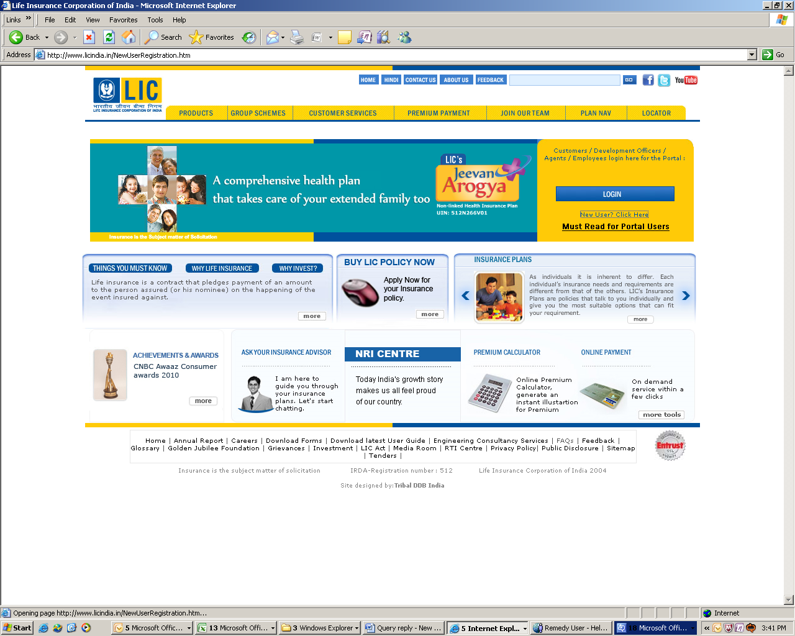
Click here

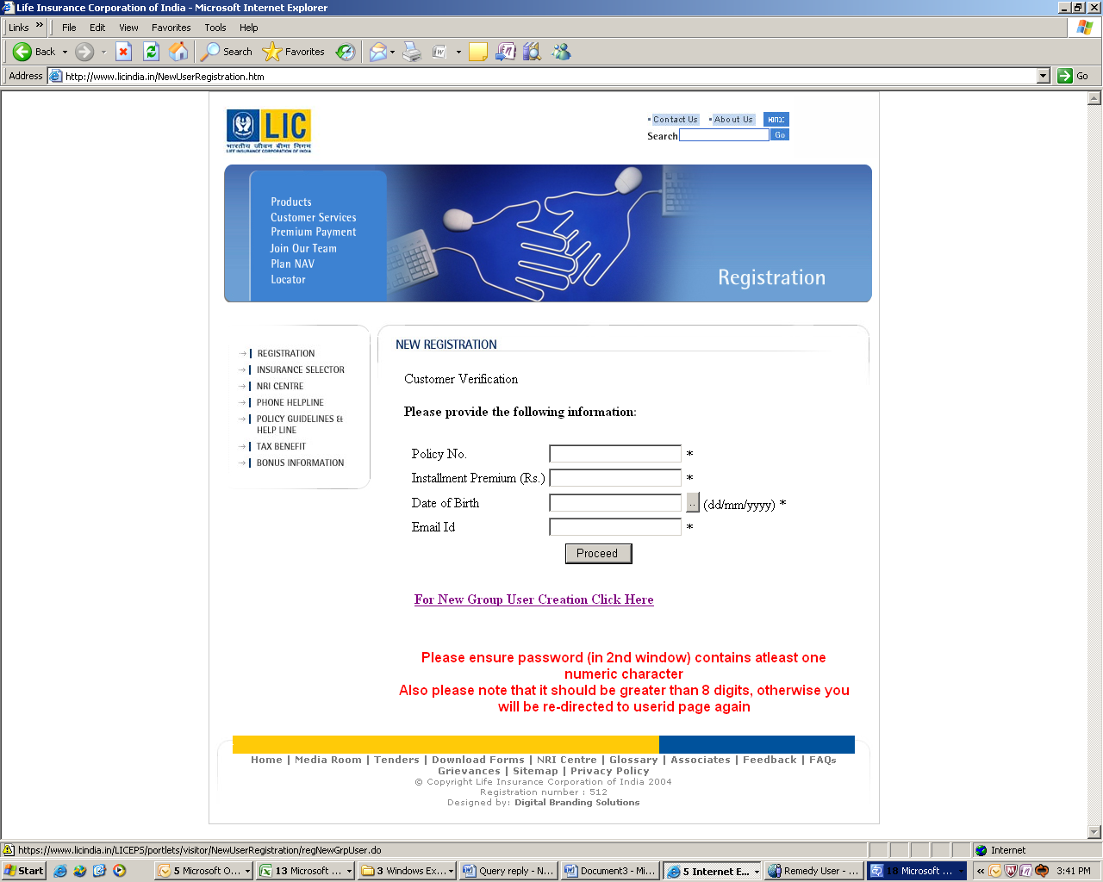
Click here

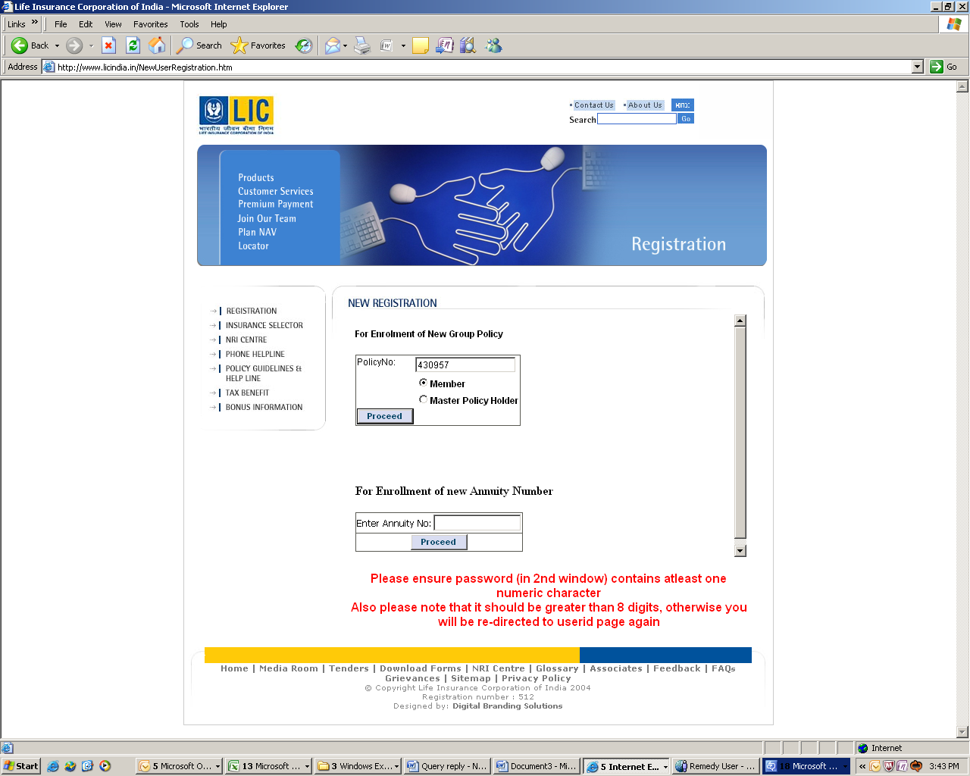
Enter the policy number that has been displayed in MyPay > MyStatements > Superannuation Slip
Select member from the option

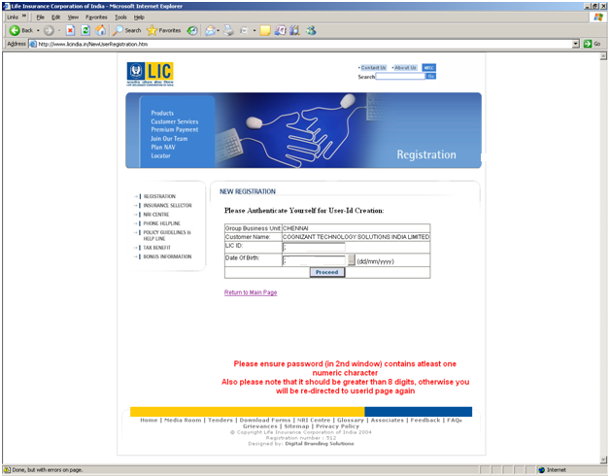
Enter the LIC ID that has been displayed in MyPay > MyStatements > Superannuation Slip
Enter your date of birth
Click proceed
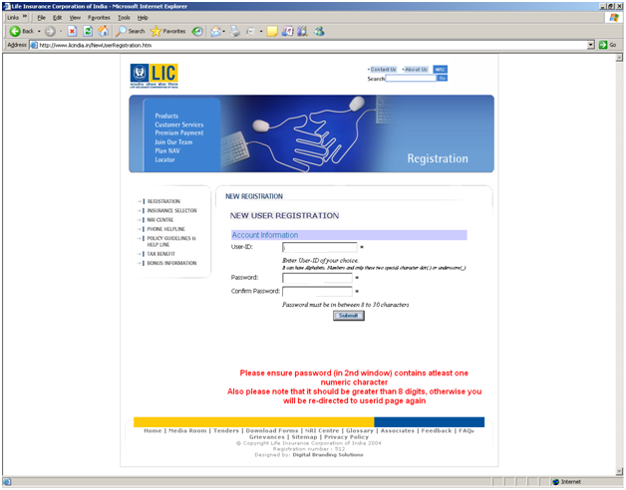
Create your own user ID and password

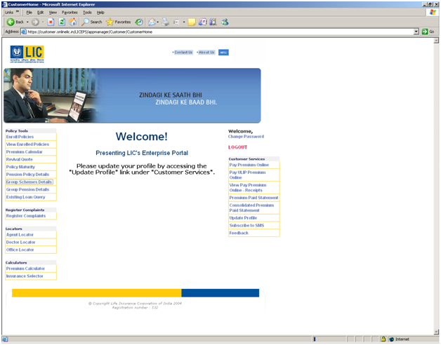
Click on group schemes details

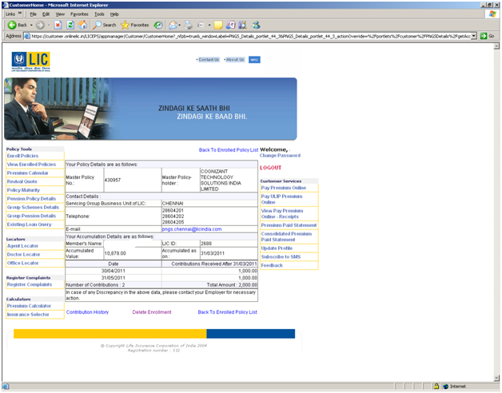
Policy details are displayed here
Click on contribution history to view all consolidated contributions

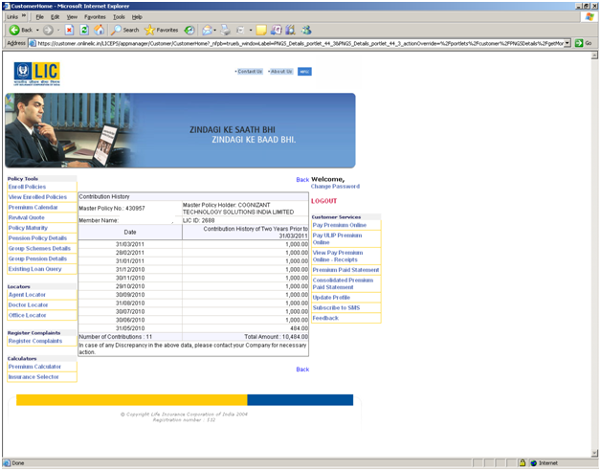
View all contributions in this page

